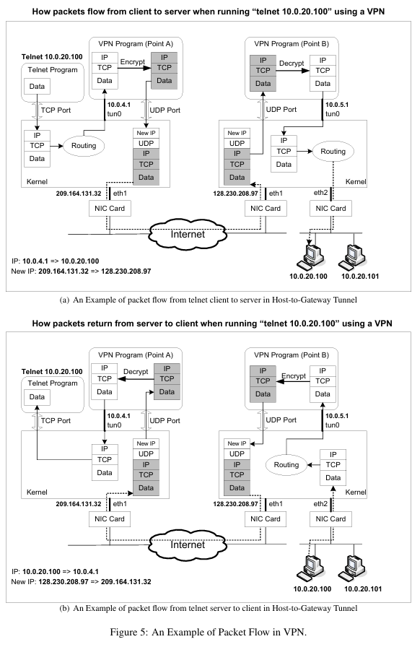
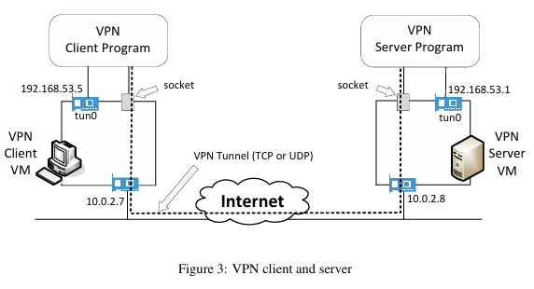

MiniVPN Lab - Task Overview

Task 1: VM Setup
- Set up 3 VMs matching Figure 3
- VPN Client VM gets IP 10.0.2.15 on NAT Network (simulates Internet)
- VPN Server VM gets IP 10.0.2.4 on the NAT Network and 192.168.60.1 on Internal Network
- Host V gets IP 192.168.60.101 on Internal Network

Task 2: Creating a VPN Tunnel using TUN/TAP
- Creates the tun0 virtual interfaces shown on both Client and Server VMs in Figure 3
- Client tun0 gets IP 192.168.53.5, Server tun0 gets IP 192.168.53.1
- The dotted line in Figure 3 represents the VPN tunnel created between the two tun0 interfaces
- Traffic flows: Application → tun0 → socket → Internet → socket → tun0 → destination

Task 3: Encrypting the Tunnel
- The socket connection shown in Figure 3 is replaced with a TLS encrypted channel
- UDP is replaced with TCP to support TLS
- All traffic passing through the tunnel (dotted line in Figure 3) is now encrypted
- Wireshark on Internet link shows encrypted/unreadable packets

Task 4: Authenticating the VPN Server
- Before the tunnel (dotted line) in Figure 3 is established, the client verifies the server's identity
- Server presents its certificate to prove it is the intended VPN Server
- Three verifications: certificate is valid, server owns certificate, server is intended server
- Prevents a fake server from intercepting the connection

Task 5: Authenticating the VPN Client
- Before the tunnel is established, server verifies the client's identity
- Client sends username and password through the encrypted TLS channel (socket in Figure 3)
- Server checks credentials against /etc/shadow
- Only authorized users can establish the tunnel shown in Figure 3

Task 6: Supporting Multiple Clients
- Multiple VPN Client VMs (like Figure 3) can connect to the same VPN Server simultaneously
- Server forks a child process for each new client connection
- Each child handles its own tunnel (dotted line) and TLS session
- Parent process routes packets from tun0 to the correct child using pipes

Extended Task: Man-in-the-Middle Attack Demonstration
- Simulated MITM setup where attacker intercepts traffic between Host U and VPN Server, presenting a forged/self-signed certificate not signed by the trusted CA
- Client-side error output shown when the forged certificate is rejected due to certificate chain verification failure
- Wireshark confirms the attacker is in the path but cannot decrypt or impersonate successfully
- The attacker can intercept TCP packets but cannot forge a certificate trusted by our CA
- Without the server's private key, the attacker cannot complete the TLS handshake in the server's name
- OpenSSL's SSL_get_verify_result() returns non-zero and our code checks this and terminates the connection

